ITEM DETAILS
Name of Item | Inter-War House
Other Name/s  Former Name/s | 7 Napier Street, Dover Heights
Item type | Built
Item group | Residential Buildings (private)
Item category | House
Area, Group, or Collection Name | Unknown
Street number | 7
Street name | Napier Street
Suburb/town | Dover Heights |  |  |  |  | Postcode |  |  | 2030
Local Government Area/s | Waverley
Property description | Lot 6 DP 14080
Location - Lat/long | Latitude | -33.872061 |  | Longitude | 151.281691
Location - AMG (if no street address) | Zone |  |  | Easting |  |  |  | Northing
Owner | Private
Current use | Residential
Former Use | Residential
Statement of significance | 7 Napier Street, Dover Heights is an altered example of a two-storey freestanding Inter-War Functionalist and Streamlined Moderne residence in Waverley. It demonstrates the 1926 resubdivision of the Dover Heights Estate by J.A.Doherty and it represents the development of the suburb during the late Inter-War period, an important phase in the history of Waverley which represents the 1920s-1930s development boom, a prominent period of economic prosperity.  The building demonstrates the pattern of change in Inter-War residences to incorporate the garage, reflecting the growth of private vehicle ownership and the lack of public transport in Dover Heights.
Level of Significance | National |  | State |  |  |  | Local

DESCRIPTION
Designer

Builder/ maker

Physical Description | 7 Napier Street, Dover Heights is a two-storey freestanding residence that dates from the late Inter-War period c1940, a key period of significance of the 1926 subdivision. The building displays features of the Inter-War Functionalist (Streamlined Moderne) style including asymmetrical massing, simple geometric shapes, horizontal emphasis (bands of windows, horizontal eaves), projecting semicircular wing, plain face-brick wall finish (recently rendered and painted). The building is setback 6 metres from the street on an average site that reflects the 1926 subdivision pattern, in a suburban setting that has partially lost its historic context. The site has a recent high palisade fence approximately 2 metres high, and a recently constructed carport forward of the residence which detract from the setting of the place. The site is formally landscaped. The building is in excellent condition and has a low integrity.  Elements impacting upon the integrity of the site includes front fence and carport, rendered wall finishes, concrete roof tiles, substantial rear additions, garage door and verandah infill.
Physical condition  and  Archaeological potential | The building appears to be in excellent condition
Construction years | Start year | 1940 | Finish year | 1940 | Circa
Modifications and dates | Original ground floor verandah (now infilled), and garage doors with a ‘porthole’ motif (now replaced).

HISTORY
Historical notes | 7 Napier Street, Dover Heights reflects part of Section F of the 1923 Dover Heights Estate, subdivided into large lots 281 feet x 310 feet and offered for auction sale in March 1886. Napier Street was subdivided as Dover Heights – Rose Bay, Bondi Estate, and advertised for auction sale in December 1916 by Raine and Horne in conjunction with J. Frank Cox & Co of Bondi Junction. Lots had 50-foot frontages and were 140-feet deep. A Building Covenant was provided. Advertisements noted the elevated position with harbour and ocean views. Re-subdivided in November 1926 by J.A.Doherty. The house was built for John Thomas Spriggins esq., milk vendor, formerly of Gilgandra Road and 135 Glenayr Avenue, Bondi. No architect is noted on the plans which were approved in October 1940. The 1943 aerial shows the house constructed.  A comparison of the 1940 plans with the existing dwelling indicates an original ground floor verandah (now infilled), and garage doors with a ‘porthole’ motif (now replaced).

THEMES
National  historical theme | 4 Building settlements, towns and cities
State  historical theme | Towns, suburbs and villages  Land tenure  Accommodation
Local  historical theme | Flats and Bungalows  Speculation and Subdivision

Assessment
A: Historical Significance | 7 Napier Street, Dover Heights has historical significance at a local level as it demonstrates the 1926 resubdivision of the Dover Heights Estate by J.A.Doherty.  7 Napier Street, Dover Heights has historical significance at a local level as it represents the development of the suburb during the late Inter-War period, an important phase in the history of Waverley which represents the 1920s-1930s development boom, a prominent period of economic prosperity.  7 Napier Street, Dover Heights has historical significance at a local level as it demonstrates the pattern of change in Inter-War residences to incorporate the garage, reflecting the growth of private vehicle ownership and the lack of public transport in Dover Heights.
B: Associative | To date, research indicates no historic association has been identified.
C: Aesthetic significance | 7 Napier Street, Dover Heights has aesthetic significance at a local level as an altered example of a two-storey freestanding Inter-War Functionalist and Streamlined Moderne residence.  The building displays features of the Inter-War Functionalist (Streamlined Moderne) styles including asymmetrical massing, simple geometric shapes, horizontal emphasis (bands of windows, horizontal eaves), and projecting semicircular wing.
D: Social significance | To date no social, cultural, and spiritual significance has been identified.
e) Technical/  Research significance | To date no technical significance has been identified.
f) Rarity | To date the research indicates 7 Napier Street, Dover Heights is not rare.
g) Representative-ness | 7 Napier Street, Dover Heights has representative significance at a local level as an altered example of a two-storey freestanding Inter-War Functionalist and Streamlined Moderne residence in Waverley.
Integrity | The building is substantially intact.

HERITAGE LISTINGS
Heritage listing/s | Draft Waverley LEP 2012

INFORMATION SOURCES
Type | Author/Client | Title | Year | Repository
 | Waverley Council | Waverley Heritage Policy | 2007
 | Waverley Council | Waverley Heritage Study | 1993
 | Perumal Murphy Pty Ltd | Waverley Heritage Study | 1990

RECOMMENDATIONS
Recommendations

SOURCE OF THIS INFORMATION
Name of study or report | Heritage Policy by Waverley Council reviewed by Architectural Projects 2023 |  | Year of study or report
Item number in study or report

Author of study or report
Inspected by
NSW Heritage Manual guidelines used? |  |  |  | Yes |  | No
This form completed by |  |  |  | Date

IMAGES

Image caption | 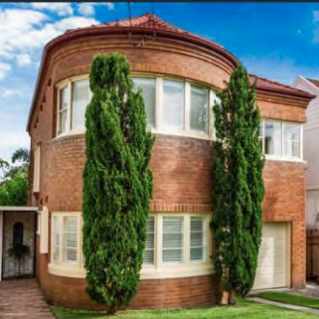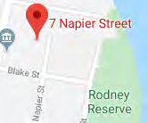
Image year |  | Image by | Google Maps | Image copyright holder

Image caption | 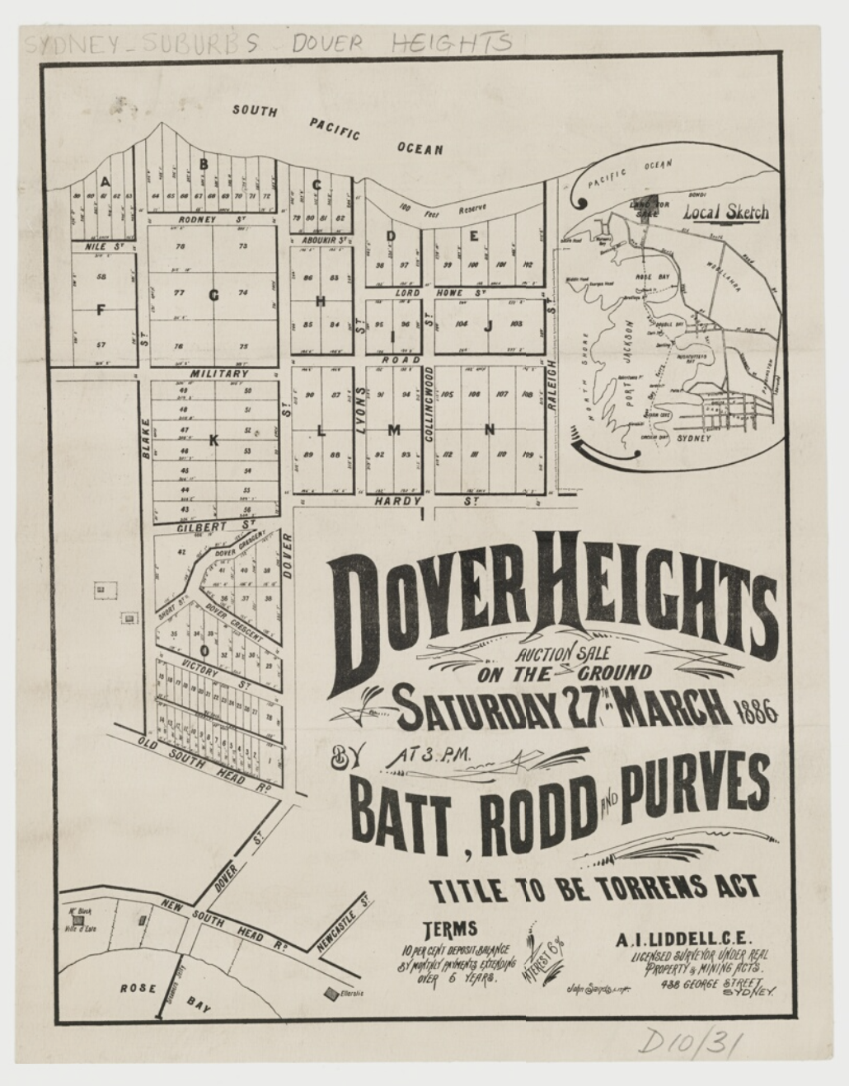
Image year | 1886 | Image by | State Library of New South Wales | Image copyright holder

Image caption | 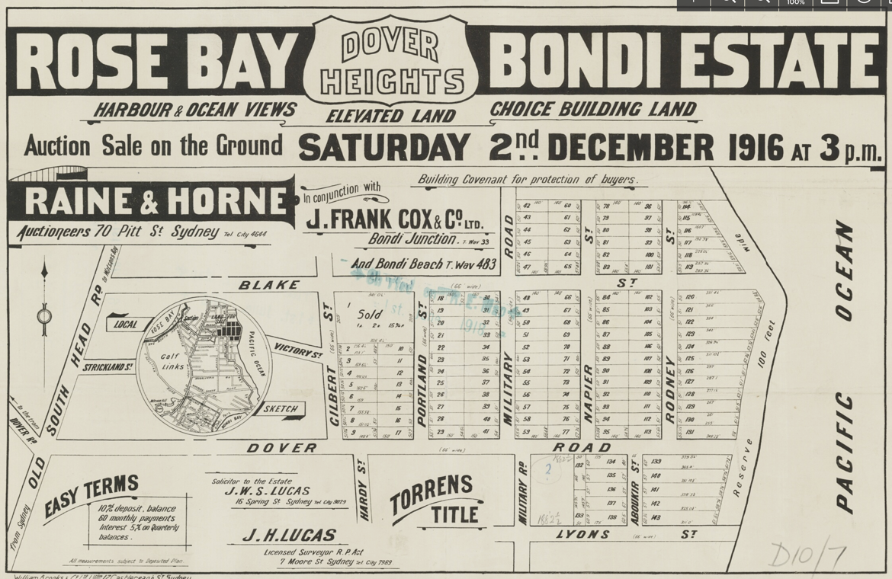
Image year | 1916 | Image by | State Library of New South Wales | Image copyright holder

Image caption | 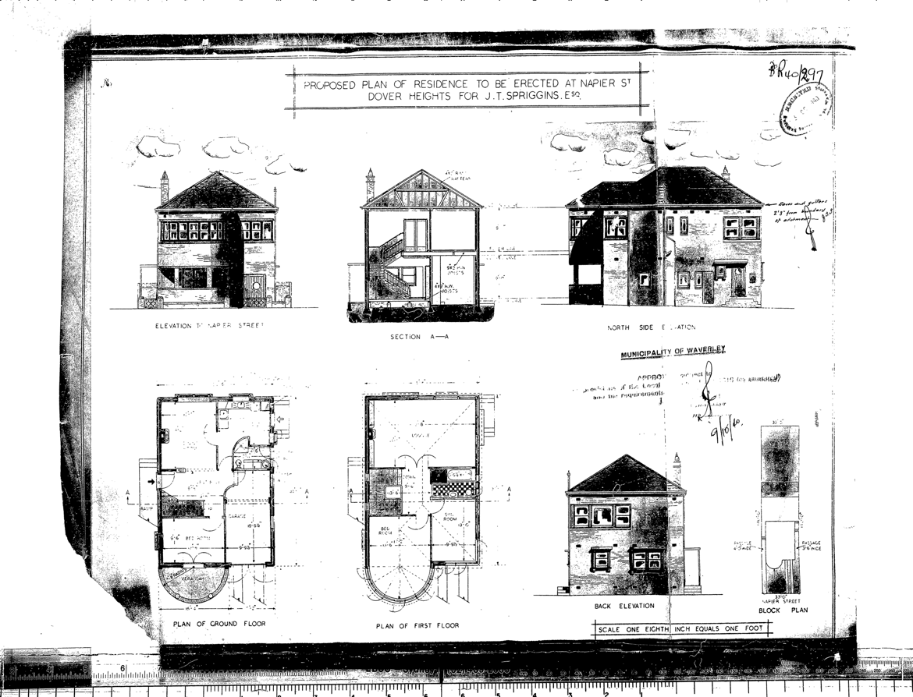
Image year | 1940 | Image by | Waverley Council | Image copyright holder

Image caption | 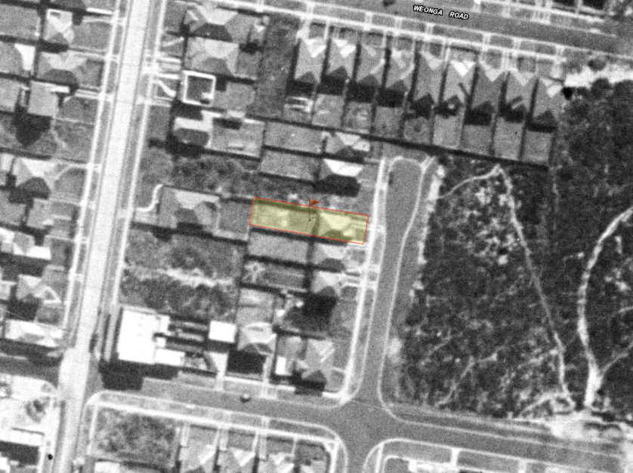
Image year | 1943 | Image by | SIX Maps | Image copyright holder

Image caption | 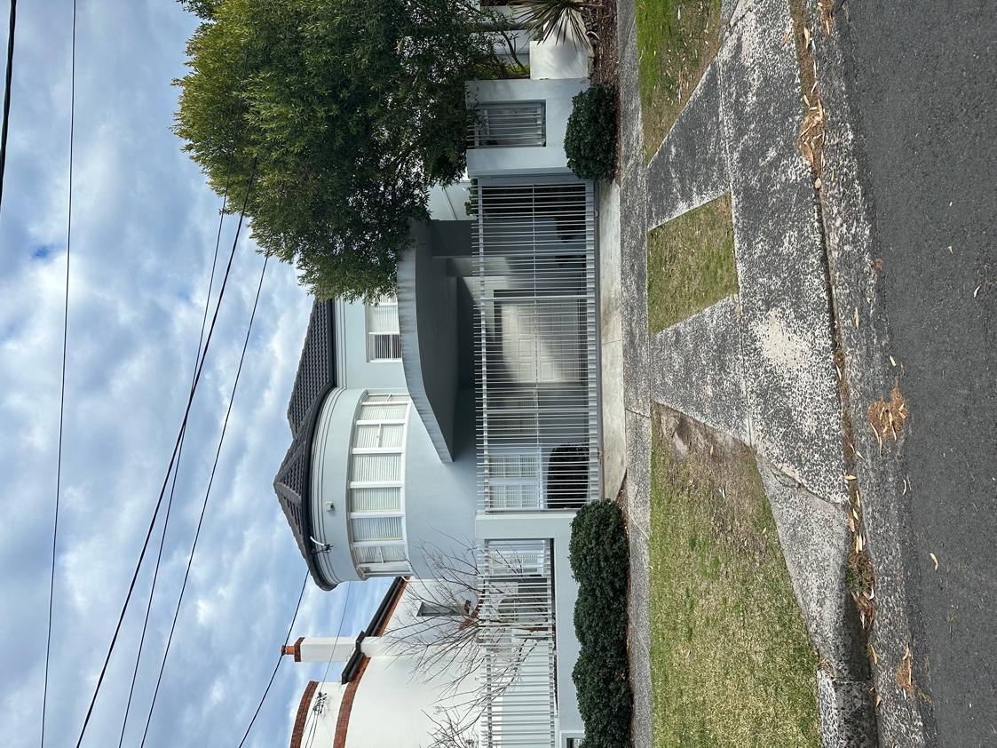
Image year | 2023 | Image by | Architectural Projects | Image copyright holder

